Author: Alyssa Pereslete

Last Updated: 3/10/19

Estimated Time: 20-25 minutes

**Materials:**

* Gloves
* 12 1.5mL aliquots from each culture flask taken at the same time as aliquots for counts
* F/2 + GeO2 media (fridge, yellow label)
* 70% ethanol
* Micro-pipette (1mL max)
* Black plate (drying next to sink)
* Plate Reader

1. Dim lab lights as much as possible.
2. See steps 1-6 of counts protocol if samples were not taken at the same time as count aliquots.
3. After counts are complete, get the black plate by the sink. It should be on a paper towel.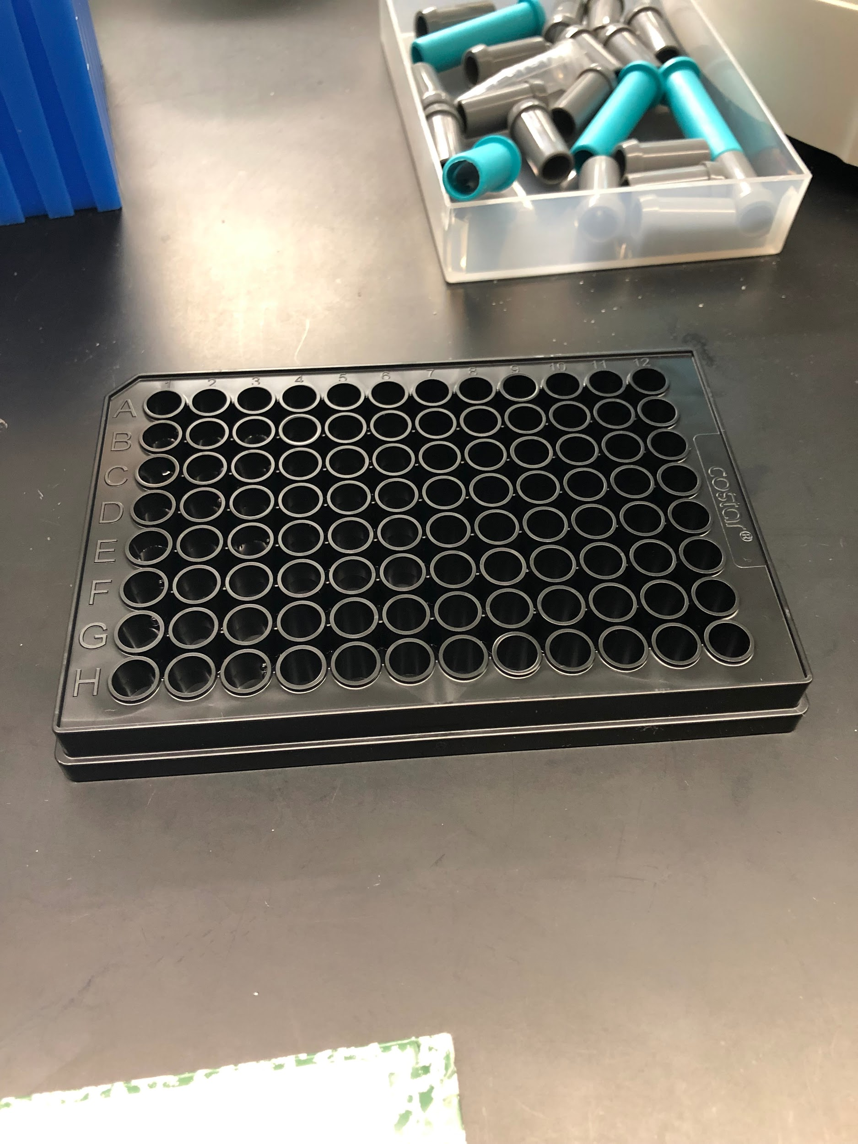
4. Wipe down entire 1mL micro-pipette with ethanol before plating media.
5. Plate 200µg of f/2 + GeO2 media as blanks in wells A1-6.
6. Vortex each aliquot for ~2 seconds.
7. Immediately plate 3 replicates of 200µg for each sample. Total of 36 samples.
   1. Plate layout is set up for samples 1-7 to be in wells B1-3 through H1-3, and samples 8-12 are in B4-6 through F4-6. see picture: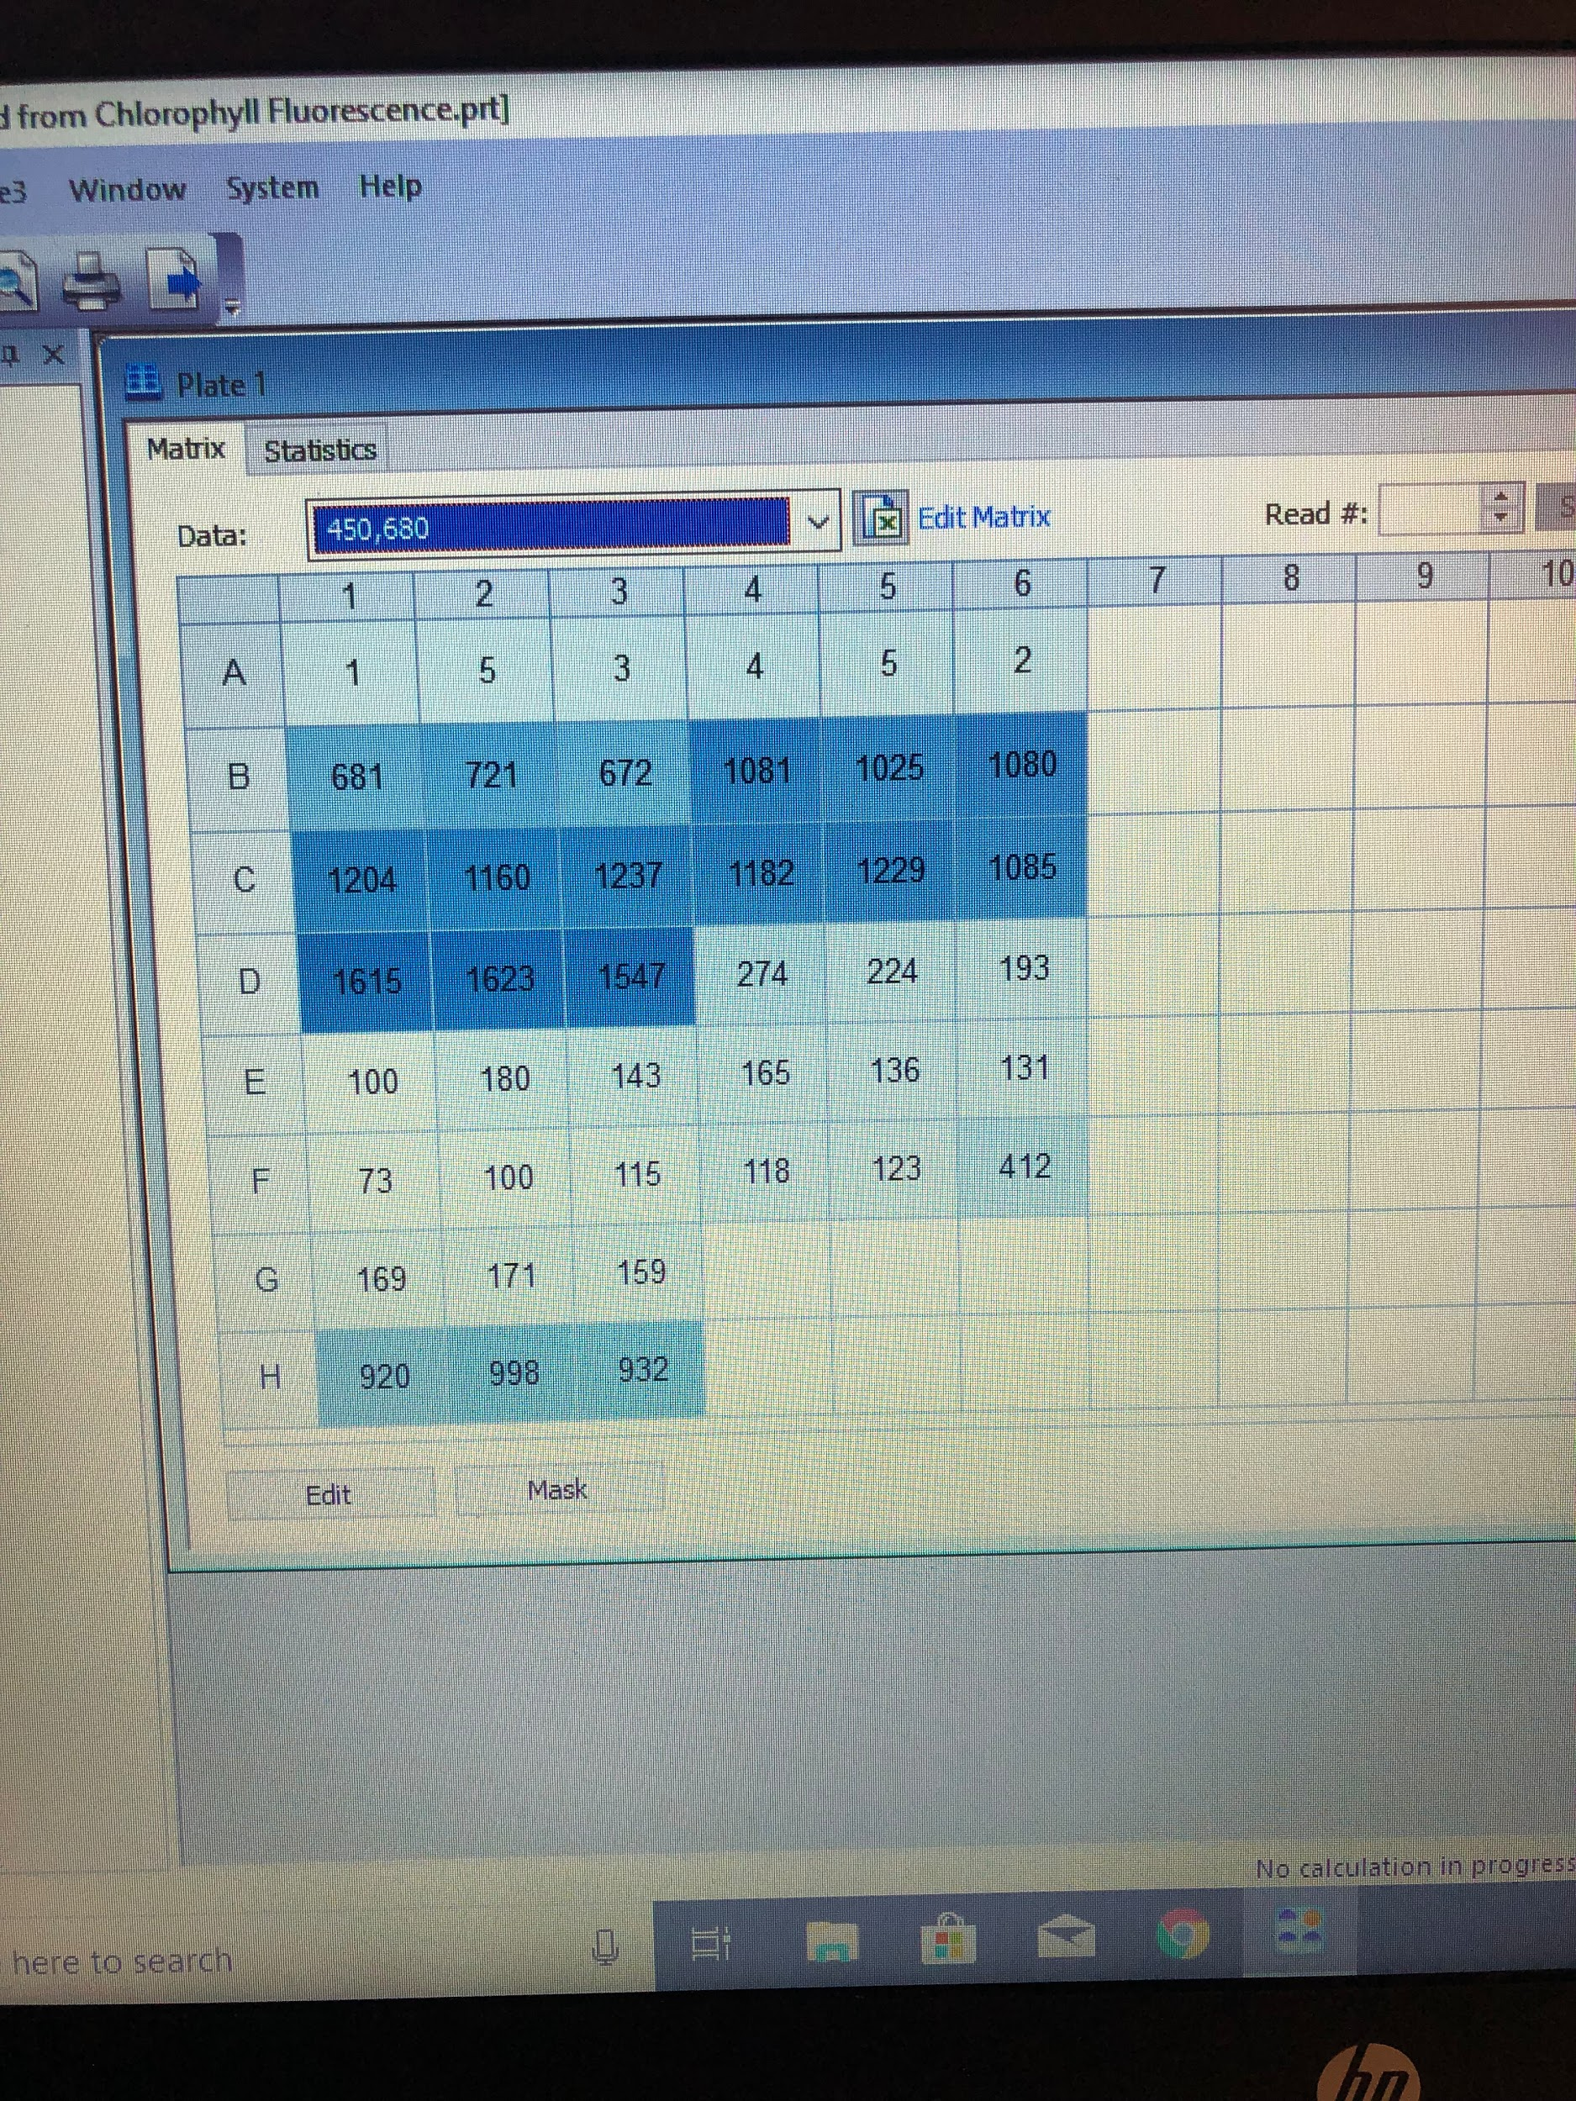
8. Place box cover over plate to incubate in darkness for 5-10 minutes.
9. Set up plate reader: There is a protocol called “chlorophyll fluorescence” that has the correct settings.
   1. Excitation: 450
   2. Emission: 680
   3. Plate layout is set up for samples 1-7 to be in wells B1-3 through H1-3, and samples 8-12 are in B4-6 through F4-6. see picture above.
10. Run plate reader, export data to excel and email file.